HELA Technical Guide
  - For contracted partners
Welcome to the HELA partner community! Thank you for joining us and helping our subscribers enjoy more for less. We look forward to a successful partnership with you.
Use this guide to sign in to your partner account, redeem a subscriber’s offer by scanning their QR code, and review your redemption statistics.

1 Open the home screen and log in
Open app.hela.gr on your device. From the home screen, select the profile icon at the bottom right to open the login screen.
Enter your partner account email address and password, then select Log in. If needed, use Forgot your password? to recover access.
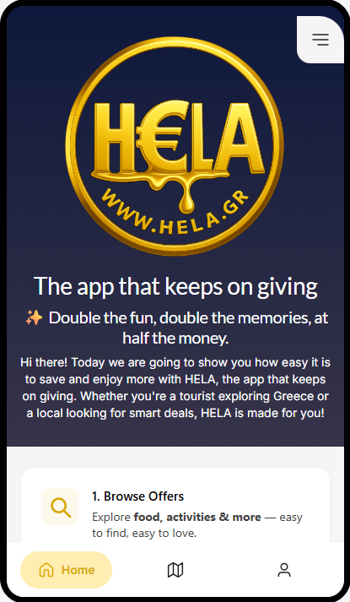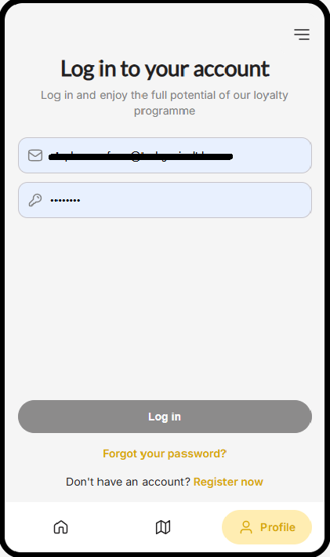
Partner device — Home screen on the left and login screen on the right

2 Find the partner controls
After logging in, open the menu using the three horizontal lines. Your partner menu provides access to SCANNER QR and ADMIN PANEL.
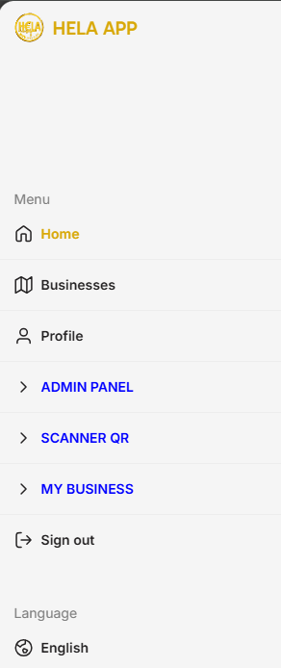
Partner device — Menu after login
SCANNER QR opens the scanner used to redeem a customer’s offer.
ADMIN PANEL opens the area where you review your business statistics.
Keep your partner login details private. Use Sign out when you finish on a shared device.

3 Check the customer offer and QR code
The HELA subscriber presents their own phone showing the offer they want to redeem at your business. Check the business name and the offer conditions before proceeding.
The subscriber then opens the offer’s QR code and shows it to your staff before paying. Keep this code visible while preparing to scan it on your partner device.
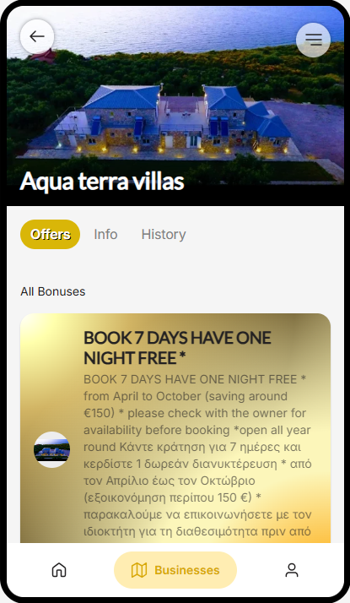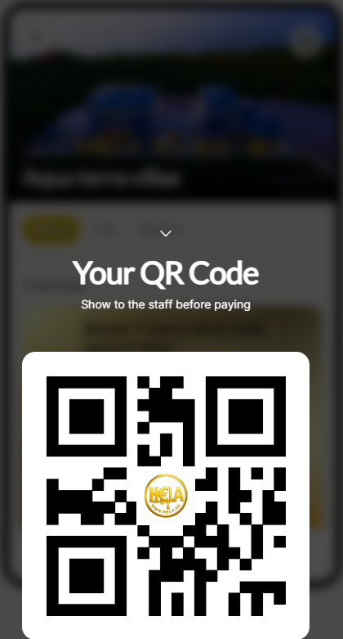
Customer phone — Offer on the left and redemption QR code on the right
The Aqua terra villas offer shown here is an example. Apply the conditions of the offer displayed for your own business.
Each offer may be redeemed only once per subscriber.

4 Scan and redeem the offer
On your partner device, return to the menu and choose SCANNER QR. Allow camera access if requested, then point the camera at the QR code displayed on the customer’s phone.
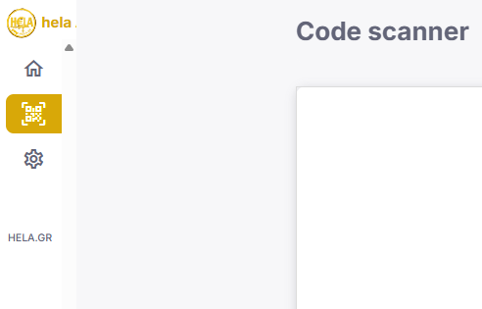
Partner device — Code scanner
After a successful scan, the customer’s QR code disappears from their phone and the offer is redeemed. Apply the agreed offer before completing payment.
If scanning does not work, check camera permission, improve the lighting, and ask the customer to increase their screen brightness. If the outcome is unclear, check the redemption record before trying again.

5 Review your statistics
Return to the partner menu and select ADMIN PANEL to open Statistics.
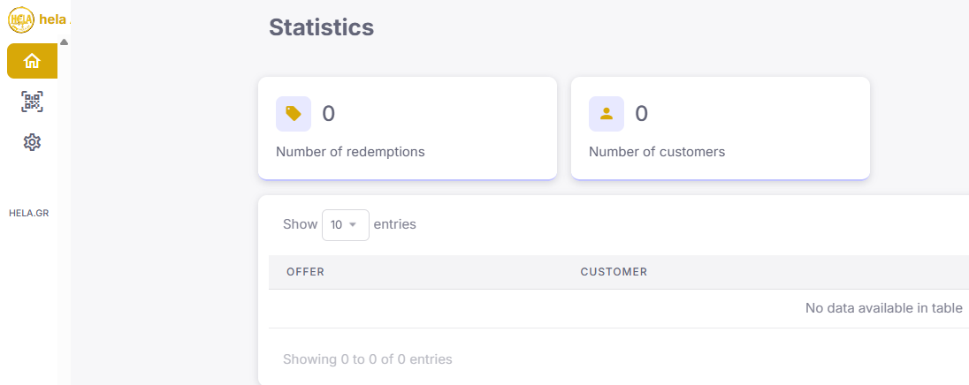
Partner device — Statistics overview and redemption records
Number of redemptions shows the redemption count. Number of customers shows the customer count. The table below lists OFFER and CUSTOMER records; use Show entries to adjust how many records are displayed.
The example screen shows zero activity. Review this panel to check your business’s recorded redemptions.

